Project Planning Phase
Project Planning Template (Product Backlog, Sprint Planning, Stories, Storypoints)

Date | 06 November 2022
Team ID | PNT2022TMID04063
Project Name | Project – IOT based smart crop protection system for agriculture
Maximum Marks | 8 Marks

Product Backlog, Sprint Schedule, and Estimation (4 Marks)
Use the below template to create product backlog and sprint schedule
Sprint | Functional Requirement (Epic) | User Story Number | User Story / Task | Story Points | Priority | Team Members
Sprint-1 | Registration | USN-1 | As a user, I can register for the application by entering my email, password, and confirming my password. | 4 | High | Krshnapriya
Sprint-1 | Registration | USN-2 | As a user, I will receive confirmation email once I have registered for the application | 3 | High | Krshnapriya
Sprint-1 | Login page | USN-3 | As a user, enter the username and password which is already existing | 3 | Medium | Bhavana
Sprint-1 | Forecasting the weather | USN-4 | As a user, we can monitor he weather conditions like humidity , temperature etc... | 12 | High | Deepika
Sprint-2 | Sensing moisture condition of the soil | USN-5 | As a user, we can know about soil moisture condition , controlling the motor pump for water flow by using mobile application. | 10 | High | Hemapriya
Sprint-3 | Detecting the motion in certain range | USN-6 | Fencing system are helpful in providing security against animals and birds. | 12 | High | Hemapriya
Sprint-4 | Checking the crops conditions. | USN-7 | Here farmer needs to update the condition of crops. | 9 | HIgh | Bhavana

Project Tracker, Velocity & Burndown Chart: (4 Marks)
Sprint | Total Story Points | Duration | Sprint Start Date | Sprint End Date (Planned) | Story Points Completed (as on Planned End Date) | Sprint Release Date (Actual)
Sprint-1 | 8 | 6 Days | 24 Oct 2022 | 29 Oct 2022 | 22 | 29 Oct 2022
Sprint-2 | 1 | 6 Days | 31 Oct 2022 | 05 Nov 2022 | 10 | 05 Nov 2022
Sprint-3 | 2 | 6 Days | 07 Nov 2022 | 12 Nov 2022 | 12 | 12 Nov 2022
Sprint-4 | 1 | 6 Days | 14 Nov 2022 | 19 Nov 2022 | 9 | 19 Nov 2022
Velocity:
Imagine we have a 10-day sprint duration, and the velocity of the team is 20 (points per sprint). Let’s calculate the team’s average velocity (AV) per iteration unit (story points per day)
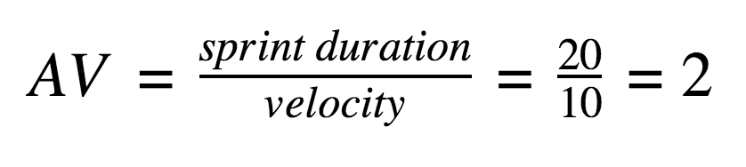
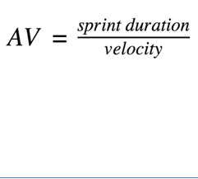
=6/13.25
=0.45

Burndown Chart:
A burn down chart is a graphical representation of work left to do versus time. It is often used in agile software development methodologies such as Scrum. However, burn down charts can be applied to any project containing measurable progress over time.

